ADVENTURE WORKS · TECHNICAL SUPPORT

Warped Rotor or Contaminated Disc Pads
Brakes Document TS-017 Rev. A
Applies to | Trailblazer MTB, Summit Trail, Velocity Road (disc), PowerRide e-Bike
Difficulty | Intermediate
Time required | 20 – 45 minutes
Tools needed | Rotor truing fork, Isopropyl alcohol & clean rag, Sandpaper (deglaze), Torque wrench

Symptoms
- A pulsing or 'wow-wow' feel through the lever when braking.
- Greatly reduced braking power, sometimes with a glassy lever feel.
- A persistent rub that returns no matter how you center the caliper.
- A burnt or oily smell from the brake after washing or lubing.
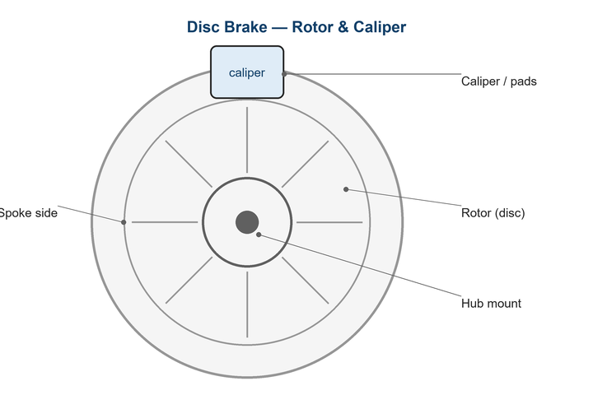
Figure 1. A true, clean rotor and uncontaminated pads are essential for power.

Likely Causes
- A bent/warped rotor from heat or an impact.
- Pads contaminated by oil, degreaser, or chain lube.
- Glazed pads from prolonged dragging.
- Loose rotor bolts allowing movement.
- Overheating on a long descent.
Safety first
- Contaminated pads can't always be cleaned — replace them if power doesn't return.
- Rotors get extremely hot; let them cool before handling.
- Keep all lubricants and sprays away from the braking system.

Customer Fix — Step by Step
Suitable for home repair with basic tools. Work through the steps in order.
- Spin the wheel and watch the rotor pass through the caliper — a side-to-side wobble indicates a warp.
- Clean the rotor with isopropyl alcohol and a clean rag; never use an oily cloth.
- If braking is weak with a glassy feel, the pads may be contaminated or glazed.
- Lightly deglaze pads by rubbing them on fine sandpaper laid flat; replace if oil has soaked in.
- Re-bed the brakes with 20–30 firm stops from moderate speed.
- If a pulsing remains, the rotor needs truing (technician step).

Technician Reference
Additional checks and adjustments for service technicians and advanced users.
- Check rotor runout with a truing fork; gently bend high spots back to within 0.2 mm.
- Re-torque 6-bolt rotors in a star pattern or check the Center-Lock lockring.
- Replace oil-contaminated pads — burning them off is unreliable and risky.
- Confirm the caliper pistons advance and retract evenly; clean and exercise sticky pistons.
- For repeated overheating, advise larger rotors or improved braking technique on descents.

Torque & Specifications
Fastener / setting | Specification
Max rotor runout | 0.2 mm
6-bolt rotor bolts | 4 – 6 N·m (star)
Center-Lock lockring | 40 N·m
Min. rotor thickness | Per rotor marking (often 1.5 mm)
Caliper mount bolts | 6 – 8 N·m

Figure 2. Even rotor runout and clean pads restore consistent stopping power.
Pro tips
- Buy a spare set of pads before long trips — contamination can end a ride.
- Wash the bike with rotors facing away from spray and degreaser.

When to Visit a Service Center
- The rotor is below minimum thickness or cracked.
- Pads are contaminated and replacement still gives weak braking.
- A caliper piston is seized.
- You lack a truing fork for a warped rotor.
This guide is provided for reference. Torque values are typical starting points — always follow the specific component manufacturer's instructions. © Adventure Works.

